**Name: Atharva Salitri Division: CSAI B**

**Roll No.: 37 PRN: 12310120**

**Subject: OS Lab Assignment 3**

**Title: Synchronisation Problems**

1. **Producer – Consumer:**

#include <stdio.h>

#include <stdlib.h>

#include <pthread.h>

#include <semaphore.h>

#define MaxItems 5

#define BufferSize 5

sem_t empty;

sem_t full;

sem_t S;

int in = 0;

int out = 0;

int buffer[BufferSize];

void *producer(void* arg)

{

int item;

for(int i = 0; i < MaxItems; i++) {

item = rand()%100;

sem_wait(&empty);

sem_wait(&S);

buffer[in] = item;

printf("Producer : Insert Item %d at %d\n",buffer[in],in);

in = (in+1)%BufferSize;

sem_post(&S);

sem_post(&full);

}

}

void *consumers(void* arg)

{

for(int i = 0; i < MaxItems; i++) {

sem_wait(&full);

sem_wait(&S);

int item = buffer[out];

printf("Consumer: Remove Item %d from %d\n",item, out);

out = (out+1)%BufferSize;

sem_post(&S);

sem_post(&empty);

}

}

int main()

{

pthread_t prod, cons;

sem_init(&empty,0,BufferSize);

sem_init(&full,0,0);

sem_init(&S,0,1);

pthread_create(&prod, NULL, (void *)producer, NULL);

pthread_create(&cons, NULL, (void *)consumers, NULL);

pthread_join(prod, NULL);

pthread_join(cons, NULL);

sem_destroy(&empty);

sem_destroy(&full);

sem_destroy(&S);

return 0;

}

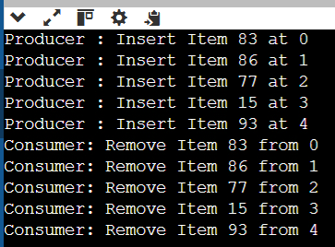

1. **Reader – Writer:**

#include <stdio.h>

#include <string.h>

#include <pthread.h>

#include <semaphore.h>

#include <stdlib.h>

#include <unistd.h>

#define BUFFER_SIZE 16

int buffer[BUFFER_SIZE];

sem_t database, mutex;

int counter, readerCount;

pthread_t readerThread[50], writerThread[50];

void init(){

sem_init(&mutex, 0, 1);

sem_init(&database, 0, 1);

counter = 0;

readerCount = 0;

}

void *writer(void *param){

sem_wait(&database);

int item;

item = rand() % 5;

buffer[counter] = item;

printf("Data writen by the writer%d is %d\n", (*(int *)param),

buffer[counter]);

counter++;

sleep(1);

sem_post(&database);

}

void *reader(void *param){

sem_wait(&mutex);

readerCount++;

if (readerCount == 1){

sem_wait(&database);

}

sem_post(&mutex);

counter--;

printf("Data read by the reader%d is %d\n", (*(int *)param),buffer[counter]);

sleep(1);

sem_wait(&mutex);

readerCount--;

if (readerCount == 0){

sem_post(&database);

}

sem_post(&mutex);

}

int main(){

init();

int no_of_writers, no_of_readers;

printf("Enter number of readers: ");

scanf("%d", &no_of_readers);

printf("Enter number of writers: ");

scanf("%d", &no_of_writers);

int i;

for (i = 0; i < no_of_writers; i++){

pthread_create(&writerThread[i], NULL, writer, &i);

}

for (i = 0; i < no_of_readers; i++){

pthread_create(&readerThread[i], NULL, reader, &i);

}

for (i = 0; i < no_of_writers; i++){

pthread_join(writerThread[i], NULL);

}

for (i = 0; i < no_of_readers; i++){

pthread_join(readerThread[i], NULL);

}

return 0;

}

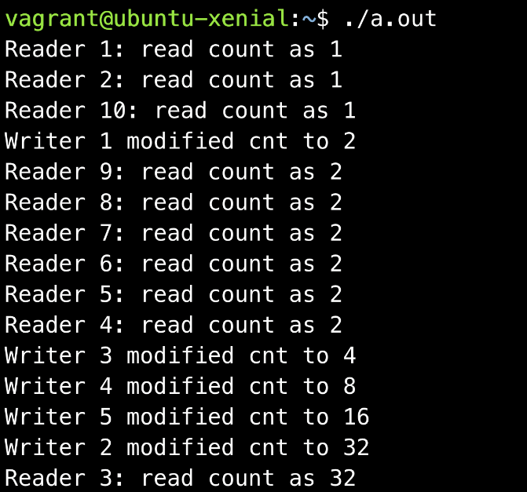

1. **Dining – Philosopher:**

#include <pthread.h>

#include <semaphore.h>

#include <stdio.h>

#include <zconf.h>

#define N 5

#define THINKING 2

#define HUNGRY 1

#define EATING 0

#define LEFT (Philosopher_ID + 4) % N

#define RIGHT (Philosopher_ID + 1) % N

int state[N];

int phil[N] = {0, 1, 2, 3, 4};

sem_t mutex;

sem_t S[N];

void Test_Dining(int Philosopher_ID) {

if (state[Philosopher_ID] == HUNGRY

&& state[LEFT] != EATING

&& state[RIGHT] != EATING) {

// Eating State

state[Philosopher_ID] = EATING;

sleep(2);

printf("Philosopher %d takes chopsticks %d and %d\n",

Philosopher_ID + 1, LEFT + 1, Philosopher_ID + 1);

printf("Philosopher %d is eating\n", Philosopher_ID + 1);

sem_post(&S[Philosopher_ID]);

}

}

// Pick up the chopsticks

void Pickup_Forks(int Philosopher_ID) {

sem_wait(&mutex);

// Hungry State

state[Philosopher_ID] = HUNGRY;

printf("Philosopher %d is hungry\n", Philosopher_ID + 1);

// Eat if adjacent neighbours are not eating

Test_Dining(Philosopher_ID);

sem_post(&mutex);

// Wait to be signalled if unable to eat

sem_wait(&S[Philosopher_ID]);

sleep(1);

}

// Put down the chopsticks

void Return_Forks(int Philosopher_ID) {

sem_wait(&mutex);

// Thinking State

state[Philosopher_ID] = THINKING;

printf("Philosopher %d putting chopsticks %d and %d down\n",

Philosopher_ID + 1, LEFT + 1, Philosopher_ID + 1);

printf("Philosopher %d is thinking\n", Philosopher_ID + 1);

Test_Dining(LEFT);

Test_Dining(RIGHT);

sem_post(&mutex);

}

void *philospher(void *num) {

while (1) {

int *i = num;

sleep(1);

Pickup_Forks(*i);

sleep(1);

Return_Forks(*i);

}

}

int main() {

int i;

pthread_t thread_id[N];

// Initialize semaphores

sem_init(&mutex, 0, 1);

for (i = 0; i < N; i++)

sem_init(&S[i], 0, 0);

for (i = 0; i < N; i++) {

// Create philosopher threads

pthread_create(&thread_id[i], NULL,

philospher, &phil[i]);

printf("Philosopher %d is thinking\n", i + 1);

}

for (i = 0; i < N; i++)

pthread_join(thread_id[i], NULL);

}

